Prerequisite :-
- GIT should be installed on your local machine .
- Path of Git should be added in Path environment variable . for ex. “C:\Program Files\Git\cmd”

GIT commands
- To add Git into folder on local machine :-
GIT init

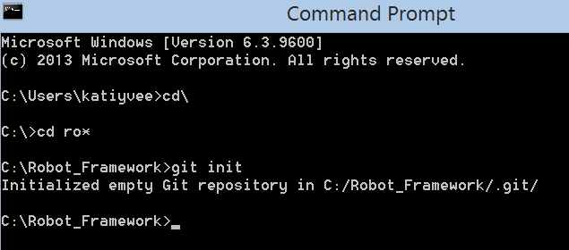

- Add files into Git :-
GIT add *.*

- To check the status of files :- The status of files are “new file”
GIT status

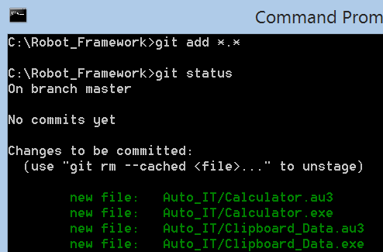

- To commit all files into GIT :-
GIT commit -m "Commit message"
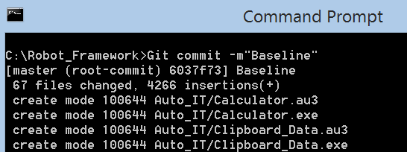

- To check the status of files :- The status of files are “On branch master”
GIT status

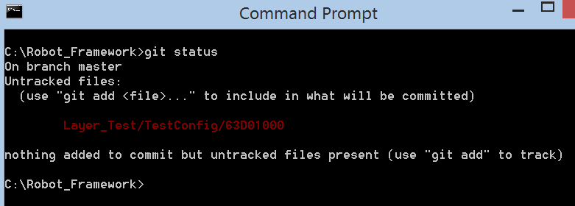

- List of your commit messages using the log command :-
GIT log

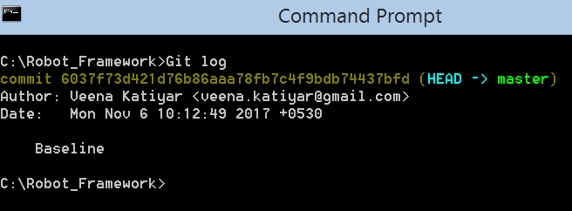

- Setting alias to remote Git repository :-
Git remote add gitRideAutomation https://git.etb.tieto.com/OFFDEVTEST/UnifiedRobotFramework.git

- Pushing local code to empty remote repository first time :-
Git push –set-upstream gitRideAutomation master

- Pushing local code to remote repository afterwards follow below mentioned commands :-
Git add *.*
Git commit -a –m ”Message”
Git push –u gitRideAutomation
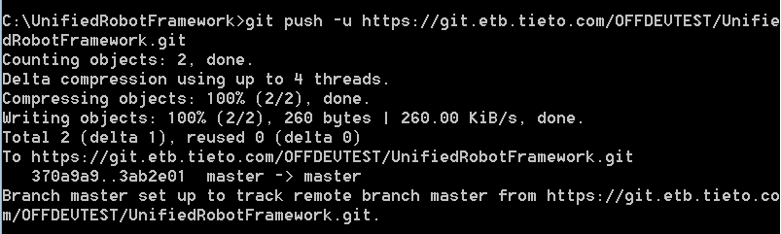

- Checking out code from remote repository first time :-
Git clone https://git.etb.tieto.com/OFFDEVTEST/UnifiedRobotFramework.git C:\Robot_Framework

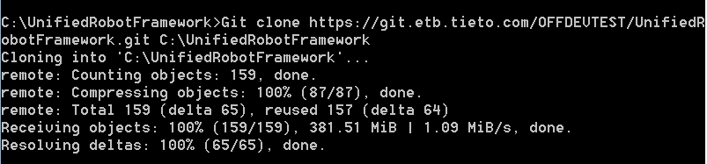

- Checking out code afterwards :-
If code at your local not in sync with Git repository . You need to take checkout before committing your changes .So, the commands will be as following :-
- Git pull https://git.etb.tieto.com/OFFDEVTEST/UnifiedRobotFramework.git
- Git add *.*
- Git commit –m “Message”
- Git push –u https://git.etb.tieto.com/OFFDEVTEST/UnifiedRobotFramework.git

- If code is in sync with Git repository and you have some new work at your local then follow below mentioned commands :-
- Git add *.*
- Git commit –m “Message”
- Git push https://git.etb.tieto.com/OFFDEVTEST/UnifiedRobotFramework.git

